About online voting in the election of faculty council members
The online voting to elect academic staff representatives to the University of Tartu faculty councils will start on 21 May at 00:00 and end on 22 May at 23:59. There will be no voting by ballot paper.
The voting is held by secret vote, and each voter has one vote. Voters can change their vote unlimited times by voting again during the voting period. The new vote cancels the vote cast during previous voting.
All persons included in the list of voters can vote at www.valimised.ut.ee using a computer or a smart device. First, choose the Estonian or English language to use the application. You can log in using your University of Tartu user name and password, digital ID or mobile-ID.
After authentication, go to the list of candidates, where you can select your preferred candidate and click the button “Next” at the bottom. The voting platform then shows your selection, asking you to confirm it by clicking “Cast vote”. After that, you will get the message that your vote has been securely cast.
Note! Please note that at the end of voting, a QR code and a message that the vote has been cast will appear on the screen – only after that your vote is registered. If you are not sure, you can always vote again.

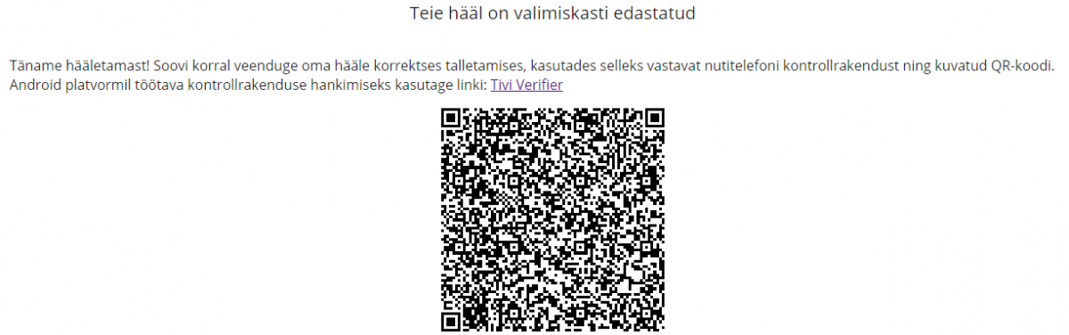

Click on the image to enlarge it. The image is merely for illustrative purposes; this QR code does not work.
A functioning network connection is required for voting. For the proper use of the voting application, choose a newer version of one of the following browsers: Google Chrome, Mozilla Firefox, Opera, Safari, Internet Explorer (version 11 or newer), and Microsoft Edge. JavaScript must be allowed in the smart device or computer.
You can check whether your vote was recorded correctly using the Tivi Verifier application, which works only on Android smart devices. The Tivi Verifier application must have the right to use the camera. If you vote using a smart device, the same device cannot be used to verify the vote.
If you have technical problems, contact the IT helpdesk on 21 and 22 May from 8 to 18 on 737 5500 or by email to arvutiabi@ut.ee.

